Mission Vision Volunteer 2024 Application Form

Name:
Phone:
Email:
Home Church:

Areas for which I wish to volunteer. Check box and circle time if applicable.
- Billeting speakers or Exhibitors
- Children’s Ministry – There are 4 one-hour sessions. If you can only help with one that would be great!
- Decorating – on Friday before conference
- Greeter for two-hour sessions
  - Friday night
    - 6pm - 8pm
  - Saturday
    - 8:30am - 10:30am,
    - 10:30am - 12:30pm,
    - 12:30pm - 2:30pm,
    - 2:30pm - 4:30pm
    - 4:30pm - 6:30pm
- Kitchen helper
  - Friday supper from 4:30pm -8pm,
  - Saturday 8am–10am, 11am-2pm & 4:30pm-8pm
  - Families are welcome to come serve together!
- Photography
- Prayer
- Security
- Set-up – 9:00 am – 1:00pm on Friday
- Take-down – between 6:30 and 9pm on Saturday evening

Mission Vision 2024

Volunteer Duties

Security – Keep Traffic flowing smoothly. Make sure that people aren’t in areas where they shouldn’t be. Check all floors for unexpected people causing disturbances.
Security shirts and radios will be provided.

Photographers – Snap pictures of basically anything and everything!
DO NOT take any pictures in children’s ministry areas (security reasons) Photographers need to be available at any time Friday and all day Saturday.

Children’s Ministry – Work with children ages 3 to 12. Sign kids in and out. Ensure there are snacks available for the kids. You must have a criminal record check done for this volunteer position.

Set Up and Cleanup Crew – Be there Friday during the day to help set up chairs and tables. Stay after the last service on Saturday to help clean up all tables and chairs and help with general clean up.

Mission Vision

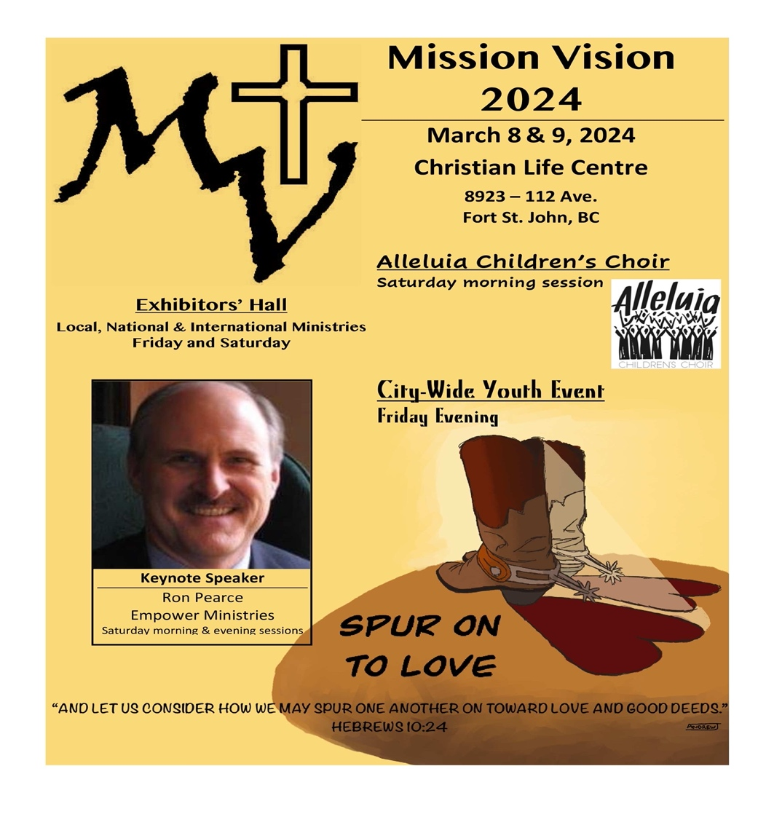

Featuring Keynote speaker, Ron Pearce with empower ministries
Mission Vision 2024

March 8th and 9TH

Volunteer Brochure
YOU,
Your Family and Friends are Invited to help make Mission Vision
an enormous success!
Fill out information and return to Volunteer Coordinator

Trudi Klassen
Box 6674
Fort St. John, BC V1J 4J1

or
Call or text: 250-261-3188 or Email: aklassen@pris.ca

